

**BUSINESS REQUIREMENTS DOCUMENT (BRD)**

**LEARNER PORTAL SYSTEM**

**Version 1.1**

**30 Oct 2018**

Table of Contents

1 INTRODUCTION 5

1.1 Business and program benefits of the project 5

1.2 High-Level Requirements 5

1.3 Assumptions 6

1.4 Risks 6

2 Scope 7

2.1 Application Context 7

2.2 Deliverables In-Scope 8

2.3 items Out of Scope: 8

2.4 Stakeholders 8

3 Functional Requirements 9

3.1 Functional requirements for Services SETA administrator 9

3.2 Functional requirements for Services SETA users 10

3.3 Functional requirement for Users 11

4 Non-Functional Requirements 12

5 business rules 12

6 system features 13

7 use case Models 14

7.1 User account management 14

7.2 contacts management 20

7.3 INESmass communication management 21

7.4 events management 23

7.5 Survey 24

7.6 reporting management 25

**Revision History**

|  |  |  |  |
| --- | --- | --- | --- |
| **Version** | **Date** | **Name** | **Description of Change** |
| **0.1** | **30 October 2018** | **Thato Modise** | **Initial Draft** |
|  |  |  |  |

**Definition of Terms and acronyms relevant to this document:**

|  |  |
| --- | --- |
| **Acronym/Term** | **Definition** |
| BRD | Business Requirements Document |
| LPS | Learner Portal System |
| SDLC | Software Development Life Cycle |
| LR | Learner Recruitment |
| Services SETA | Services Sector Education and Training Authority |
|  |  |
|  |  |
|  |  |
|  |  |

**Stakeholders**

|  |  |  |
| --- | --- | --- |
| **Stakeholder Name** | **Title** | **Email** |
| Shireen Raju | LIPC Manager | [ShireenR@serviceseta.org.za](mailto:ShireenR@serviceseta.org.za) |
| Mduduzi Zakwe | Senior IT Manager | [mduduziz@serviceseta.org.za](mailto:mduduziz@serviceseta.org.za) |
| Angelo Castro | Officer |  |
|  |  |  |
|  |  |  |
|  |  |  |
|  |  |  |
|  |  |  |
| Tebello Mokoena | Chambers Operations | [tebellom@serviceseta.org.za](mailto:tebellom@serviceseta.org.za) |
| Thembinkosi Mosia | Chambers Operations | [thembinkosim@serviceseta.org.za](mailto:thembinkosim@serviceseta.org.za) |
| Lerato Mbonani | Chambers Operations | [leratom@serviceseta.org.za](mailto:leratom@serviceseta.org.za) |
| Nomfezeko Vendle | Chambers Operations | [Nomfezekov@serviceseta.org.za](mailto:Nomfezekov@serviceseta.org.za) |
| Andile Sipengane | Head of Core Business | [Andiles@serviceseta.org.za](mailto:Andiles@serviceseta.org.za) |
| Vusi Nkosi | Provincial Operations | [Vusin@serviceseta.org.za](mailto:Vusin@serviceseta.org.za) |

# INTRODUCTION

Service SETA interacts with a number of stakeholders in their day to day operations. Currently there is no central system that manages the stakeholder information and the interaction/communication with the stakeholders. As a result, a project was initiated to develop a stakeholder database system to manage all the stakeholders that the services SETA interacts with.

The system should be able to manage all the stakeholder information and provide a mechanism to send communications to all the stakeholders.

The system should further provide a reporting capability to enable the administrator to create operational reports.

## Business and program benefits of the project

**The following benefits have been identified:**

* Single View of the Truth in terms of information.
* Self-Services capabilities for Employers, SDP, Assessors, Moderators and Learners to interact with Services SETA.
* Smooth and effortless online reporting capability.
* Reporting Timeously.
* Effective Communication Tracking.
* Latest True and Validated contact details from reliable and authorized sources.
* Online help.

## High-Level Requirements

**SDBMS** must include the following:

* Ability to allow both internal and external users to access the application without downloading any software.
* Ability to create all internal and external user roles / groups to allow segregation of duties.
* Ability to interface with existing applications.
* Ability to incorporate automated routing and notifications based on configured roles.
* Ability to allow all strategic partners like Assessors, Moderators and Skills Development Providers, skills development Facilitators, Employers and Staff to self-register Online, from anywhere they desire.
* Ability to view Analytics Reports.
* Ability to manage calendar and events details.
* Ability to Search any contact information related to SDF, SDP, Assessor, Moderator, Employer, etc.

## Assumptions

**The following project risks have been identified:**

* Services SETA will provide details of the Business requirements and ensure completeness through a review process as agreed by both parties.
* Services SETA will provide Hardware Infrastructure for production, according to Letheric’s recommended Specification by the 30th May 2018.
* Software Infrastructure licensing will be provided by Services SETA.
* Integration Interfaces for LMIS should be made available if required.

## Risks

**The following project risks have been identified:**

* Delays in sign-off will results in project timelines being missed.
* This will affect business in effectively communicating to their stakeholders.

# Scope

# Scope

## Application Context

The full SMDBS context is shown in the following diagram with the scope of this BRD indicated.

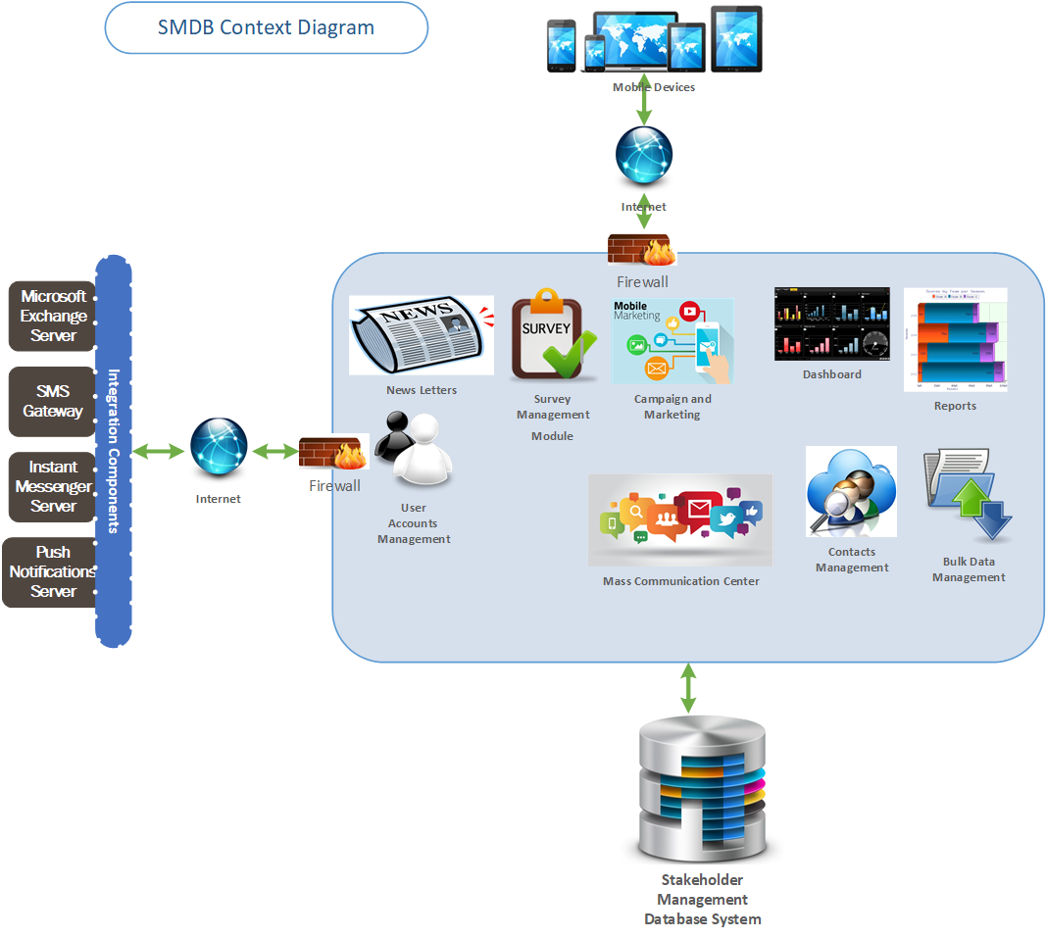

## Deliverables In-Scope

SDBMS provides a means to Services SETA to communicate/interact with their stakeholders effectively and timeously.

* Provide a database system to manage all stakeholder information
* Provide a capability for managing the information on the stakeholder database system
* Provide a capability for sending mass communications to the stakeholders on the database
  + Using SMS communication channel
  + Using Email communication channel
  + Instant messaging
  + Push notifications
* Provide a capability to enable the administrator to create operational reports
  + Survey Reports
  + Users Access Reports
  + List of Contact Details Reports for All Stakeholders
  + RSVP Reports (Optional)
  + Sent Messages Reports
  + Statistical Reports (Services SETA to design report required)

## items Out of Scope:

* LMIS System Development
* Learner Portal System Development

## Stakeholders

**The following categories of stakeholders have been identified for inclusion in the system:**

* Levy paying Employers
* Non-levy paying Employers
* Skills Development Providers
* Skills Development Facilitator
* Assessors and Moderators
* Learners
* Chambers
* Planning
* Public further education and training institutions
* Government departments

# Functional Requirements

Functional requirements detail the system’s intended capabilities, appearance, and interactions with users

This section provides the list of functional requirements that the system should cater for. The requirements will be listed with a reference number for easy reference in the system design, test documents and all other documents that makes reference to the system functionality.

## Functional requirements for Services SETA administrator

|  |  |  |  |  |
| --- | --- | --- | --- | --- |
| **Requirement ID** | **Description** | **Priority** | **Stakeholders Affected** | |
| **ADM001** | User should be able to create user accounts | High | System Administrator | |
| **ADM002** | User should be able to maintain user accounts | High | System Administrator | |
| **ADM003** | User should be able to configure the application theme | High | System Administrator | |
| **ADM004** | User should be able to configure the email server | High | System Administrator | |
| **ADM005** | User should be able to configure the SMS gateway | High | System Administrator | |
| **ADM006** | User should be able to configure the instant messaging Gateway | High | System Administrator | |
| **ADM007** | User should be able configure the push notifications server | High | System Administrator | |
| **ADM008** | User should have audit trail level configuration privileges | High | System Administrator | |
| **ADM009** | Users should be able bulk import contacts | High | | System Administrator, Provincial Office System Administrator |

## Functional requirements for Services SETA users

|  |  |  |  |
| --- | --- | --- | --- |
| **Requirement ID** | **Description** | **Priority** | **Stakeholders Affected** |
| **ST001** | Users Should be able to Self Register | High | SETA Staff |
| **ST002** | Users should be able to Reset Password | High | SETA Staff |
| **ST003** | Users should be able to maintain their Profile | High | SETA Staff |
| **ST005** | Users should be able to create stakeholder user profiles | High | SETA Staff |
| **ST006** | Users should be able to maintain stakeholder user profiles | High | SETA Staff |
| **ST005** | Users should be able to subscribe/Unsubscribe to Newsletters | High | SETA Staff |
| **ST006** | Users should be able to create and send Newsletters | High | SETA Staff |
| **ST007** | Users should be able to create SMS messages | High | SETA Staff |
| **ST008** | Users should be able to send SMS messages | High | SETA Staff |
| **ST009** | Users should be able to create push notifications | Medium | SETA Staff |
| **ST010** | Users should be able to send push notifications | Medium | SETA Staff |
| **ST011** | Users should be able to create events | Medium | SETA Staff |
| **ST012** | Users should be able to send event invites | Medium | SETA Staff |
| **ST013** | Users should be able to create group chats | Low | SETA Staff |
| **ST014** | Users should be able to delete group chats | Low | SETA Staff |
| **ST015** | Users should be able to create surveys | High | SETA Staff |
| **ST016** | Users should be able send surveys and receive survey responses | High | SETA Staff |
|  |  |  |  |

## Functional requirement for Users

|  |  |  |  |
| --- | --- | --- | --- |
| **Requirement ID** | **Description** | **Priority** | **Stakeholders Affected** |
| **FR001** | Users should be able to self-register on the system | High | Employers, Assessors, Moderators, Skills Development Providers, Skills Development Facilitators, SETA Staff and Researchers |
| **FR002** | Users should be able to manage their passwords | High | Employers, Assessors, Moderators, Skills Development Providers, Skills Development Facilitators, SETA Staff and Researchers |
| **FR003** | Users should be able to maintain their profile including deleting the account | High | Employers, Assessors, Moderators, Skills Development Providers, Skills Development Facilitators, SETA Staff and Researchers |
| **FR004** | Users should be able to Subscribe/Unsubscribe to Newsletters | High | Employers, Assessors, Moderators, Skills Development Providers, Skills Development Facilitators, SETA Staff and Researchers |
| **FR006** | Users should be able to Subscribe/Unsubscribe to receive SMS communication | High | Employers, Assessors, Moderators, Skills Development Providers, Skills Development Facilitators, SETA Staff and Researchers |
| **FR007** | Users should able to Subscribe/Unsubscribe to receive push notifications | High | Employers, Assessors, Moderators, Skills Development Providers, Skills Development Facilitators, SETA Staff and Researchers |
| **FR008** | Users should be able to accept/reject invitations to group chats | High | Employers, Assessors, Moderators, Skills Development Providers, Skills Development Facilitators, SETA Staff and Researchers |
| **FR009** | Users should be able to exit group chats | High | Employers, Assessors, Moderators, Skills Development Providers, Skills Development Facilitators, SETA Staff and Researchers |
| **+-** |  |  |  |

# Non-Functional Requirements

|  |  |  |  |
| --- | --- | --- | --- |
| **Requirement ID** | **Requirement Category** | **Priority** | **Description** |
| **NFR001** | Performance | High | System should load Home Page in 5 – 8 seconds |
| **NFR002** | Access Security | High | The System should not allow anonymous users access. All users should register. |
| **NFR003** | Segregation of Duties | High | The System should be secure and have capabilities to segregate duties. Staff Members and Stakeholders should not have the same access to the system. |
| **NFR004** | System Availability | High | System Uptime should be 99.98 %. The 0.02 is take into account maintenance and support to be conducted on the system. |
| **NFR005** |  | High | The System should have a look and feel that is aligned with Services SETA’s CI. |

# business rules

The Table below lists and describes the applicable business rules:

| **Rule ID** | **Traceability to FR** | **Business Rule** | **Rule Description** |
| --- | --- | --- | --- |
| R001 | FR | Message Delivery Confirmations | Functionality must be provided to track all the communication that has been sent to stakeholders |
|  |  |  |  |

# system features

The diagram below shows a list of features to be developed for the solution:

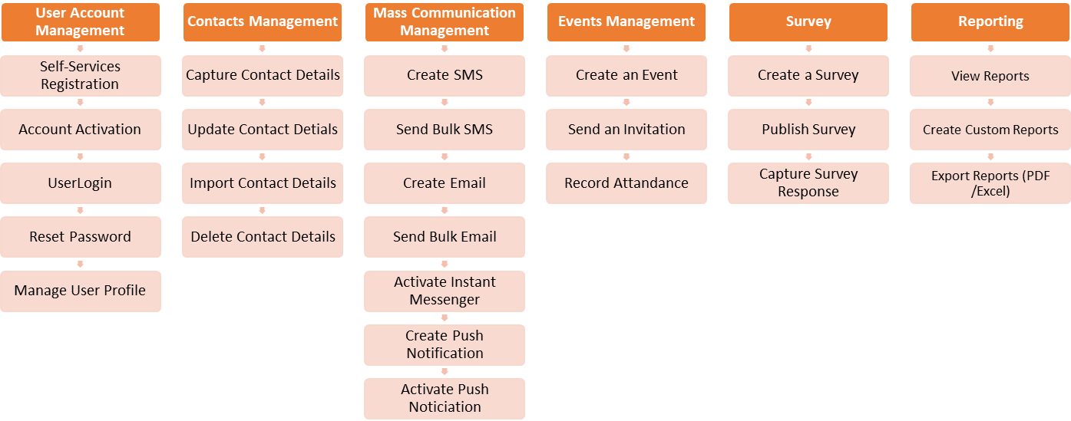

# use case Models

## User account management

* **Use Case List:**

| Use Case # | Use Case Name | Description | Users |
| --- | --- | --- | --- |
| UCA-01 | *Register as User* | Users registers themselves online. | Staff, SDF, SDP, CAM, Employers |
| UCA-02 | *Activate Account* | Users clicks on an Email to activate their online account. | Staff, SDF, SDP, CAM, Employers |
| UCA-03 | *User Login* | Users should be able to login once their accounts are activated. | Staff, SDF, SDP, CAM, Employers |
| UCA-04 | *Reset Password* | Users should be able to reset their password when they forgot their current passwords. | Staff, SDF, SDP, CAM, Employers |
| UCA-05 | *Manage user Profile* | Users should be able to Update their Profile details at any time. | Staff, SDF, SDP, CAM, Employers |

* **Use Case Diagram:**



* **Use Case Description – Register as a user :**

| **Use Case Name** | **Register as a user** | | | **Use Case No.:** | **UC011** | |
| --- | --- | --- | --- | --- | --- | --- |
| **Description** | The Search Function is available for the user to search for any specific information related to CyberSecurity without having to go through each page. | | | | | |
| **Primary Actor** | User | | | | | |
| **Secondary Actor** | CyberSecurity Website | | | | | |
| **Goal in Context** | When the user searches for information, the required information is displayed. | | | | | |
| **Level of Complexity** | L = Low | M = Medium | | H -= High | | |
| Low |  | |  | | |
| **Pre-conditions** | The user must be on the internet. | | | | | |
| **Post-conditions** | The information relating to the searched text should be displayed. | | | | | |
| **Trigger** | The user requires information on CyberSecurity. | | | | | |
| **Normal course of action** | | | | | | |
| **Step** | **Action (by Actor)** | | **System Response** | | | **Ref** |
| **1.** | The user enters text and selects the search button on the CyberSecurity website. | | Information (hits) relating to the user’s search query is displayed. | | |  |
| **2.** | The user will select the links displayed on the screen. | | A new page will appear with the required information. | | |  |
| **Exception course of action 1** | | | | | | |
| **Step** | **Action (by Actor)** | | **System Response** | | | **Ref** |
| **1.** | The user enters text and the CyberSecurity website is unable to find information relation to the entered text. | | *Error message –* ***“No search results could be found for query”*** *will be displayed.* | | |  |
| **Exception course of action 2** | | | | | | |
| **1.** | The user clicks on the links displayed and not data is displayed. | | Display *“*404 error message page” | | |  |
|  | | | | | | |

* **Use Case Description – Activate account :**

| **Use Case Name** | **Activate account** | | | **Use Case No.:** | **UC011** | |
| --- | --- | --- | --- | --- | --- | --- |
| **Description** | The Search Function is available for the user to search for any specific information related to CyberSecurity without having to go through each page. | | | | | |
| **Primary Actor** | User | | | | | |
| **Secondary Actor** | CyberSecurity Website | | | | | |
| **Goal in Context** | When the user searches for information, the required information is displayed. | | | | | |
| **Level of Complexity** | L = Low | M = Medium | | H -= High | | |
| Low |  | |  | | |
| **Pre-conditions** | The user must be on the internet. | | | | | |
| **Post-conditions** | The information relating to the searched text should be displayed. | | | | | |
| **Trigger** | The user requires information on CyberSecurity. | | | | | |
| **Normal course of action** | | | | | | |
| **Step** | **Action (by Actor)** | | **System Response** | | | **Ref** |
| **1.** | The user enters text and selects the search button on the CyberSecurity website. | | Information (hits) relating to the user’s search query is displayed. | | |  |
| **2.** | The user will select the links displayed on the screen. | | A new page will appear with the required information. | | |  |
| **Exception course of action 1** | | | | | | |
| **Step** | **Action (by Actor)** | | **System Response** | | | **Ref** |
| **1.** | The user enters text and the CyberSecurity website is unable to find information relation to the entered text. | | *Error message –* ***“No search results could be found for query”*** *will be displayed.* | | |  |
| **Exception course of action 2** | | | | | | |
| **1.** | The user clicks on the links displayed and not data is displayed. | | Display *“*404 error message page” | | |  |
|  | | | | | | |

* **Use Case Description – Log into system :**

| **Use Case Name** | **Log into system** | | | **Use Case No.:** | **UC011** | |
| --- | --- | --- | --- | --- | --- | --- |
| **Description** | The Search Function is available for the user to search for any specific information related to CyberSecurity without having to go through each page. | | | | | |
| **Primary Actor** | User | | | | | |
| **Secondary Actor** | CyberSecurity Website | | | | | |
| **Goal in Context** | When the user searches for information, the required information is displayed. | | | | | |
| **Level of Complexity** | L = Low | M = Medium | | H -= High | | |
| Low |  | |  | | |
| **Pre-conditions** | The user must be on the internet. | | | | | |
| **Post-conditions** | The information relating to the searched text should be displayed. | | | | | |
| **Trigger** | The user requires information on CyberSecurity. | | | | | |
| **Normal course of action** | | | | | | |
| **Step** | **Action (by Actor)** | | **System Response** | | | **Ref** |
| **1.** | The user enters text and selects the search button on the CyberSecurity website. | | Information (hits) relating to the user’s search query is displayed. | | |  |
| **2.** | The user will select the links displayed on the screen. | | A new page will appear with the required information. | | |  |
| **Exception course of action 1** | | | | | | |
| **Step** | **Action (by Actor)** | | **System Response** | | | **Ref** |
| **1.** | The user enters text and the CyberSecurity website is unable to find information relation to the entered text. | | *Error message –* ***“No search results could be found for query”*** *will be displayed.* | | |  |
| **Exception course of action 2** | | | | | | |
| **1.** | The user clicks on the links displayed and not data is displayed. | | Display *“*404 error message page” | | |  |
|  | | | | | | |

* **Use Case Description – Reset password :**

| **Use Case Name** | **Reset password** | | | **Use Case No.:** | **UC011** | |
| --- | --- | --- | --- | --- | --- | --- |
| **Description** | The Search Function is available for the user to search for any specific information related to CyberSecurity without having to go through each page. | | | | | |
| **Primary Actor** | User | | | | | |
| **Secondary Actor** | CyberSecurity Website | | | | | |
| **Goal in Context** | When the user searches for information, the required information is displayed. | | | | | |
| **Level of Complexity** | L = Low | M = Medium | | H -= High | | |
| Low |  | |  | | |
| **Pre-conditions** | The user must be on the internet. | | | | | |
| **Post-conditions** | The information relating to the searched text should be displayed. | | | | | |
| **Trigger** | The user requires information on CyberSecurity. | | | | | |
| **Normal course of action** | | | | | | |
| **Step** | **Action (by Actor)** | | **System Response** | | | **Ref** |
| **1.** | The user enters text and selects the search button on the CyberSecurity website. | | Information (hits) relating to the user’s search query is displayed. | | |  |
| **2.** | The user will select the links displayed on the screen. | | A new page will appear with the required information. | | |  |
| **Exception course of action 1** | | | | | | |
| **Step** | **Action (by Actor)** | | **System Response** | | | **Ref** |
| **1.** | The user enters text and the CyberSecurity website is unable to find information relation to the entered text. | | *Error message –* ***“No search results could be found for query”*** *will be displayed.* | | |  |
| **Exception course of action 2** | | | | | | |
| **1.** | The user clicks on the links displayed and not data is displayed. | | Display *“*404 error message page” | | |  |
|  | | | | | | |

* **Use Case Description – Manage user profile :**

| **Use Case Name** | **Log into system** | | | **Use Case No.:** | **UC011** | |
| --- | --- | --- | --- | --- | --- | --- |
| **Description** | The Search Function is available for the user to search for any specific information related to CyberSecurity without having to go through each page. | | | | | |
| **Primary Actor** | User | | | | | |
| **Secondary Actor** | CyberSecurity Website | | | | | |
| **Goal in Context** | When the user searches for information, the required information is displayed. | | | | | |
| **Level of Complexity** | L = Low | M = Medium | | H -= High | | |
| Low |  | |  | | |
| **Pre-conditions** | The user must be on the internet. | | | | | |
| **Post-conditions** | The information relating to the searched text should be displayed. | | | | | |
| **Trigger** | The user requires information on CyberSecurity. | | | | | |
| **Normal course of action** | | | | | | |
| **Step** | **Action (by Actor)** | | **System Response** | | | **Ref** |
| **1.** | The user enters text and selects the search button on the CyberSecurity website. | | Information (hits) relating to the user’s search query is displayed. | | |  |
| **2.** | The user will select the links displayed on the screen. | | A new page will appear with the required information. | | |  |
| **Exception course of action 1** | | | | | | |
| **Step** | **Action (by Actor)** | | **System Response** | | | **Ref** |
| **1.** | The user enters text and the CyberSecurity website is unable to find information relation to the entered text. | | *Error message –* ***“No search results could be found for query”*** *will be displayed.* | | |  |
| **Exception course of action 2** | | | | | | |
| **1.** | The user clicks on the links displayed and not data is displayed. | | Display *“*404 error message page” | | |  |
|  | | | | | | |

## contacts management

* Use Case List

| Use Case # | Use Case Name | Description | Users |
| --- | --- | --- | --- |
| UCC-06 | *Capture Contacts Details* | Users should be able to capture their contact details if logged-in | Staff, SDF, SDP, CAM, Employers |
| UCC-07 | *Update Contact Details* | Users should be able to update their contain details if logged-in | Staff, SDF, SDP, CAM, Employers |
| UCC-08 | *Delete Contact Details* | Users should be able to delete their contact details if logged-in | Staff, SDF, SDP, CAM, Employers |
| UCC-09 | *Import Contact Details* | Users should be able to bulk import Stakeholder details | Staff, SDF, SDP, CAM, Employers, Provincial System Administrator |

* Use Case Diagram



## INESmass communication management

* Use Case List

| Use Case # | Use Case Name | Description | Users |
| --- | --- | --- | --- |
| UCM-10 | *Create SMS* | Users should be able to create and SMS messages | Staff |
| UCM-11 | *Send Bulk SMSes* | Users should be able to send bulk sms messages to a specified group of stakeholders | Staff |
| UCM-12 | *Create Email* | Users should be to create and send emails | Staff |
| UCM-13 | *Send Bulk Emails* | Users should be able to send bulk emails to a specified group of stakeholders | Staff |
| UCM-14 | *Activate Instant Messenger* | Users should be able to enable the functionality to send instant messages | Staff, SDF, SDP, CAM, Employers |
| UCM-15 | *Send Instant Messages* | Users should be able to send instant messages to other users | Staff, SDF, SDP, CAM, Employers |
| UCM-16 | *Create Push Notification* | Users should be able to create push notifications | Staff |
| UCM-17 | *Activate Push Notification* | Users should be able to specify which instant messages are active | Staff |
| UCM-18 | *Send Push Notifications* | Users should be able to send push notifications | Staff |
| UCM-18.1 | *View Push Notification* | Users should be able to view the published push notifications | Staff, SDF, SDP, CAM, Employers |

* Use Case Diagram



## events management

* **Use Case List**

| Use Case # | Use Case Name | Description | Users |
| --- | --- | --- | --- |
| UCE-19 | *Create an Event* | Users should be able to create an event | Staff |
| UCE-20 | *Send an Invitation* | Users should be able to send event invitation to stakeholders | Staff |
| UCE-21 | *Record Attendance* | User should be able to record event attendance on the system | Staff, SDF, SDP, CAM, Employers |

* **Use Case Diagram**



## Survey

* **Use Case List**

| Use Case # | Use Case Name | Description | Users |
| --- | --- | --- | --- |
| UCS-22 | *Create Survey* | Users should be able to create surveys | Staff |
| UCS-23 | *Publish Survey* | Users should be able to send surveys to Stakeholders | Staff |
| UCS-24 | *Capture Survey Response* | Users should be able to record survey responses | Staff, SDF, SDP, CAM, Employers |

* **Use Case Diagram**



## reporting management

* **Use Case List**

| Use Case # | Use Case Name | Description | | Users |
| --- | --- | --- | --- | --- |
| UCS-25 | *View Reports* | Users should be able to view pre-configure reports | Staff | |
| UCS-26 | *Create Custom Reports* | Users should be able to create custom operational reports | Staff | |
| UCS-27 | *Export Reports (PDF /Excel)* | Users should be able to export system reports | Staff | |

* **Use Case Diagram**

